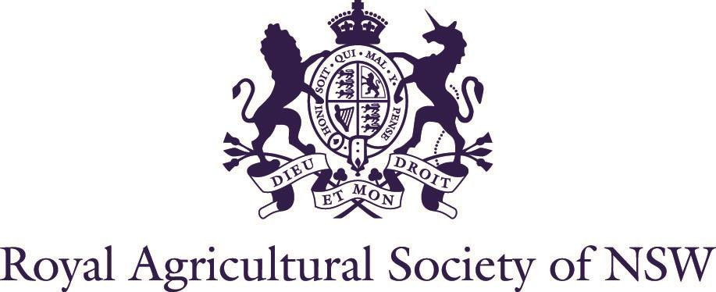

BUDGET MOTELS

Ibis Budget Sydney Olympic Park
(3 star) 02 9648 3862 (700m)
Edwin Flack Avenue, Sydney Olympic Park
http://www.ibis.com/gb/hotel-6582-ibis-budget-sydney-olympic-park/index.shtml

Parramatta City Motel
(3½ star) 02 9635 7266 (8km)
40-44 Great Western Highway, Parramatta
https://www.parramattacitymotel.com.au/

175 One Hotels and Apartments

(3 star) 02 9635 1233 (11.1km)
175 Hawkesbury Road, Westmead
https://oneha.com.au/175/

Ibis Budget Wentworthville
(3 star) 02 9631 9161 (10.9km)
377-383 Great Western Highway, Wentworthville
https://ibisbudgetwentworthville.reservationstays.com/requests/5MrCfBEQYONV2McqJl0c3Q/hotels/xWeErx3W?expand_params=true

The Select Inn Ryde
(3½ Star) 02 9877 8377 (8km) 1188 Victoria Road,
West Ryde
https://www.theselectinnryde.com.au/

Metro Inn Ryde
(3½ star) 02 9807 4022 (7.7km)
860 Victoria Road (corner Bowden Street), Ryde http://rydeinn.com.au/

Liberty Plains Motel
(3½ star) 02 8719 0619 or 0434 962 141(3.2km)
5 Olympic Drive, Lidcombe NSW 2141
http://www.libertymotorinn.com.au/

North Ryde Guest House
(3 star) 02 9878 1896 (11.1km) 22 David Avenue, North Ryde

PUBS
Woolpack Hotel
02 9635 8043 (8.4km)
19 George Street, Parramatta http://woolpackhotel.com.au/

Ranch Hotel
02 9887 2411 (12.3km)
108 Herring Road, North Ryde
https://nightcaphotels.com.au/hotels/nsw/nightcap-at-the-ranch

Concord Hotel Concord West
02 9736 1891 (4.3km)
39 Victoria Avenue, Concord West
https://www.concordhotel.com.au/stay

Markets Hotel

02 9764 3500 (2.7km)
268 Parramatta Rd, Homebush West
http://www.marketshotel.com.au/

Golf View Hotel Motel
02 9632 9758 (8.4km)
150 Rawson Road, Guildford https://www.golfviewhotel.com.au/

Crown on McCredie Hotel

02 9632 1888 (13.1km)
135 Fairfield Road (corner McCredie Road), Guildford West https://www.crownonmccredie.com.au/#accommodation

Melton Hotel
02 9748 2634 (3.7km)
163 Parramatta Road, Auburn https://www.meltonhotel.com.au/accommodation

Wentworth Hotel
02 9746 6400 (2.6km)
195 Parramatta Road, Homebush West
https://wentworthhotel.com.au/accommodation/

CARAVAN PARKS

Lane Cove River Tourist Park

02 9888 9133 (12.5km)
13 Plassey Road, Macquarie Park
https://www.discoveryholidayparks.com.au/caravan-parks/new-south-wales/sydney-lane-cove

Australian Community Villages Bass Hill
02 9724 9670 (12.4km)
713 Hume Highway, Bass Hill
https://www.booking.com/Share-GI1cop

QUALITY HOTELS

Holiday Inn Parramatta
(4 star) 02 9891 1277 (8km)
18-40 Anderson Street, Parramatta
https://www.holidayinn.com/hotels/gb/en/parramatta/sydpa/hoteldetail?fromRedirect=true&qSrt=sBR&qIta=99602090&icdv=99602090&qSlH=SYDPA&setPMCookies=true&qSHBrC=HI&qDest=18-40+Anderson+Street%2C+Parramatta%2C+NSW%2C+AU&dp=true&gclid=Cj0KCQjwt_qgBhDFARIsABcDjOdGSxP5XjKB0urmUBfxSLKbtOmNhxdDad-dAVky9TlLae_eLeJC_N0aAm66EALw_wcB&cm_mmc=PDSEA-_-G_F-JAPAC_FS-AUNZ_H-JAPAC_HS-AUS_HI_BRI_EXM_HOTEL-SYDPA&srb_u=1

Novotel Sydney Parramatta
(4 star) 02 9630 4999 (10.8km)
350 Church Street, Parramatta
https://all.accor.com/hotel/8787/index.en.shtml?utm_campaign=seo+maps&utm_medium=seo+maps&utm_source=google+Maps

Park Royal
(4 star) 02 9689 3333 (11km)
30 Phillip Street, Parramatta
https://www.panpacific.com/en/hotels-and-resorts/pr-parramatta.html?utm_source=google&utm_medium=business_listing&utm_campaign=googlemybusiness

Mercure Sydney Parramatta
(4 star) 02 8836 1000 (6.5km)
106 Hassall Street, Rosehill
https://all.accor.com/hotel/2123/index.en.shtml?utm_campaign=seo+maps&utm_medium=seo+maps&utm_source=google+Maps

Rydges Hotel
(4½ star) 02 8863 7600 (6.4km) 116-118 James Ruse Drive, Rosehill
https://www.rydges.com/accommodation/sydney-nsw/parramatta/?utm_source=google&utm_medium=organic&utm_campaign=gmb

Mercure Sydney Macquarie Park
(4 star) 02 7255 1900 (13.8km)
81 Talavera Road, North Ryde
https://all.accor.com/hotel/B976/index.en.shtml?utm_campaign=seo+maps&utm_medium=seo+maps&utm_source=google+Maps

Courtyard by Marriott North Ryde
(4 star) 02 9491 9500 (11.7km)
7-11 Talavera Road, North Ryde
https://www.marriott.com.au/hotels/travel/sydry-courtyard-sydney-north-ryde/

Crowne Plaza Burwood

1800 007 697 (7.6km)
60 Burwood Rd, Burwood NSW 2134
https://www.ihg.com/crowneplaza/hotels/us/en/burwood/sydrb/hoteldetail?cm_mmc=GoogleMaps-_-CP-_-AU-_-SYDRB

Quest Sydney Olympic Park
(4 star) 02 9033 2000 (750m) 6 Edwin Flack Avenue, Sydney Olympic Park
https://www.questapartments.com.au/properties/nsw/sydney-olympic-park/quest-at-sydney-olympic-park/hotel-rooms

Holiday Inn Express Macquarie Park
(4 star) 02 9428 9500 (15.8km)
10 Byfield Street, North Ryde
https://www.ihg.com/holidayinnexpress/hotels/us/en/sydney/sydmp/hoteldetail

Novotel Sydney Olympic Park
(4 star) 02 8762 1111 (250m)
11 Olympic Boulevard, Sydney Olympic Park
http://www.accorhotels.com/gb/hotel-2732-novotel-sydney-olympic-park/index.shtml

Pullman Sydney Olympic Park
(5 star) 02 8762 1700 (300m)
9 Olympic Boulevard, Sydney Olympic Park
https://all.accor.com/hotel/6411/index.en.shtml?utm_campaign=seo+maps&utm_medium=seo+maps&utm_source=google+Maps

APARTMENTS

Absolute Waterfront Apartments
02 8843 1300 (7.7km)
103 George Street, Parramatta
www.waterfront-apartments.com.au

Mantra Suites

02 9685 1600 (8.1km)
Corner Parkes Street and Valentine Avenue, Parramatta
www.mantraparramattahotel.com.au

Meriton Serviced Apartments
1800 214 822 (7.7km)
180 George Street (cnr Charles St), Parramatta
www.meriton.com.au

Fiori Apartments
02 9806 0800 (7.7km)
13-15 Hassall St, Parramatta www.fioriapartments.com.au

Parkside Apartments
02 9894 0751 (11km)
35 Grose Street, North Parramatta
www.parksidesydney.com

Meriton Serviced Apartments North Ryde
02 8488 9000 (12.8km)
88 Talavera Road, North Ryde
https://www.meritonsuites.com.au/our-hotels/nsw/northern-sydney/north-ryde/?utm_source=google&utm_medium=organic&utm_campaign=google-my-business

Eastwood Serviced Apartments
1300 030 001 (11km)
2/4 May Street, Eastwood
https://eastwood-furnished-apartments.com.au/contact/

Astra Rhodes
1300 797 321 (5km)
46 Walker Street, Rhodes
https://www.astraapartments.com.au/

Oaks Sydney North Ryde

(4 star) 02 8899 8888 (12.2km)
58-62 Delhi Road, North Ryde
https://www.oakshotels.com/en/oaks-sydney-north-ryde-suites

