 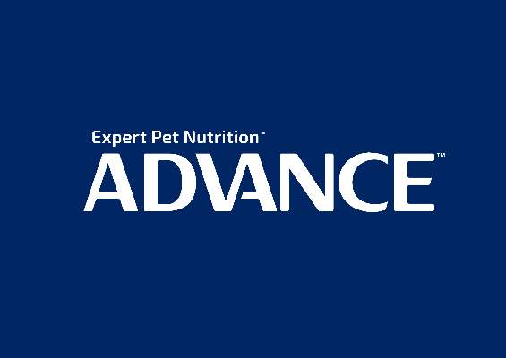

**2022 ADVANCE™ Sydney Royal Dog Show and the 2022 ADVANCE™ Sydney Royal Cat Show**

ADVANCE™ is pleased to be a key partner of the Sydney Royal Easter Show and major sponsor of the Sydney Royal Dog and Cat Shows.

It is our privilege to take part in these traditions of animal excellence that have resonated with Australians for over a century. We’re dog and cat lovers at heart who create only the best products for our pets. Therefore, we believe that there’s no one-size-fits-all approach to caring for our pets, so we have used our expertise to develop tailored nutrition to help them grow and thrive.

Thinking of adding a furry family member or want to know which food is right for your pets? Our team will be at the Pet Pavilion every day to discuss any pet nutrition questions you have.

Plus, a day at the Show isn’t complete without visiting the ADVANCE™ Bark Park, featuring breeds of all personalities, shapes and sizes for you to meet.

We look forward to seeing you at Sydney Olympic Park!

The ADVANCE™ team

www.advancepet.com.au