 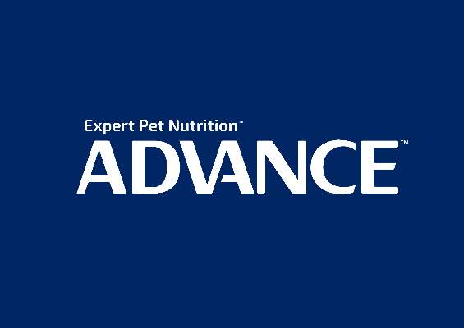

**2021 ADVANCE™ Sydney Royal Dog Show and the 2021 ADVANCE™ Sydney Royal Cat Show**

ADVANCE™ is pleased to be the major sponsor of the Sydney Royal Dog and Cat Shows, and we look forward to seeing you at Sydney Olympic Park.

Pets make the world a better place and the team at ADVANCE™ want to make the world a better place for pets through providing expert pet nutrition. We believe that one size doesn’t fit all so we have used our expertise to understand the unique needs of Australian pets. Decades of scientific research and expertise are incorporated into our nutritionally complete and balanced formulas, offering pet parents a reliable and consistent meal of guaranteed quality and performance.

At Australia’s most prestigious show, ADVANCE™ will present prizes to all winners and our expert teams will be on site every day to talk to pet parents about health, care and nutrition. Advice about selecting the right dog or cat for potential pet owners will be on hand in the **ADVANCE™ BARK PARK,** which is right next to the dog show rings, featuring breeds of all personalities, shapes and sizes for the public to meet.

ADVANCE™ has been recommended by Australia’s #1 breeder for over ten years, as well as the #1 show dog consistently in Australia, a true testament to the superior formulation of ADVANCE™. We are here to help all breeders reach their full potential, with our proudly Australian super premium products and breeder program.

The ADVANCE™ team welcomes all breeders and exhibitors into the **ADVANCE™ hospitality lounge** to relax. Our brand Ambassador Team will be on hand to discuss all nutrition related topics, from raising litters to conditioning that special show dog in the pursuit of excellence. Our team looks forward to greeting you each day.

Finally, we wish all exhibitors much success at the show, and hope that you all take home great memories and stories to tell of your time at the Sydney Royal Easter Show!

Anne Raymond

National Breeder Relations Manager

www.advancepet.com.au